Q1:
import java.io.*;
import java.util.Scanner;
import java.util.ArrayList;
public class q1 {
public static void main(String[] args) throws IOException {
ArrayList<String> list = new ArrayList();
Scanner sc=new Scanner(System.in);
for(int i=0;i<=4;i++){
String input;
System.out.println("Enter the String");
input = sc.next();
list.add(input);
}
BufferedWriter br=new BufferedWriter(new FileWriter("Question1.txt"));
for (int i=0;i<=4;i++) {
br.write(list.get(i));
br.write("\n");
}
br.close();
BufferedReader br2=new BufferedReader(new FileReader("Question1.txt"));
ArrayList<String> list2=new ArrayList<>();
String line;
while((line=br2.readLine())!=null) {
list2.add(line);
}
br2.close();
for (String s:list2) {
System.out.println(s);
}
}
}
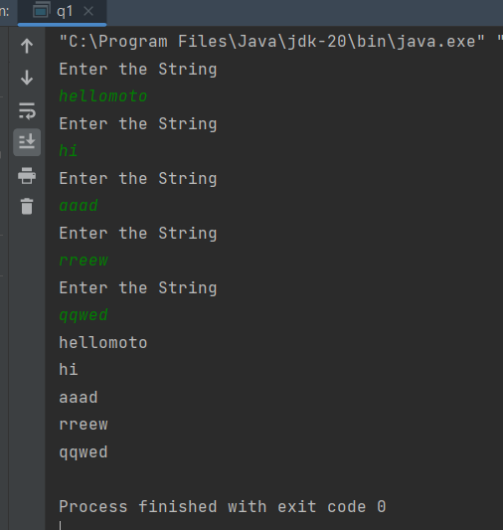
Q2:
import java.io.File;
import java.io.FileWriter;
import java.io.IOException;
import java.util.ArrayList;
import java.util.Scanner;
class StudentRegistration {
public static void main(String[] args) {
Scanner input = new Scanner(System.in);
System.out.print("Student's full name: ");
String name = input.nextLine();
System.out.print("Student's ID: ");
String id = input.nextLine();
String filename = name + "OOP LAB 11.txt";
File file = new File(filename);
try {
FileWriter writer = new FileWriter(file);
writer.write("Name: " + name + "\n");
writer.write("ID: " + id + "\n");
ArrayList<String> courses = new ArrayList<>();
System.out.print("Enter PF Lab marks: ");
int pflab = input.nextInt();
System.out.print("Enter PF Theory marks: ");
int pftheory = input.nextInt();
if (pflab >= 50 && pftheory >= 50) {
courses.add("PF Lab");
courses.add("PF Theory");
System.out.print("Enter OOP Lab marks: ");
int ooplab = input.nextInt();
System.out.print("Enter OOP Theory marks: ");
int ooptheory = input.nextInt();
if (ooplab >= 50 && ooptheory >= 50) {
courses.add("OOP Lab");
courses.add("OOP Theory");
}
}
int totalCredits = 0;
for (String course : courses) {
writer.write(course + "\n");
totalCredits += 3;
}
if (totalCredits > 15) {
System.out.println("Warning: Student has registered for more than 15 credits.");
}
writer.close();
Scanner reader = new Scanner(file);
while (reader.hasNextLine()) {
String line = reader.nextLine();
System.out.println(line);
}
reader.close();
} catch (IOException e) {
System.out.println("An error occurred.");
e.printStackTrace();
}
input.close();
}
}

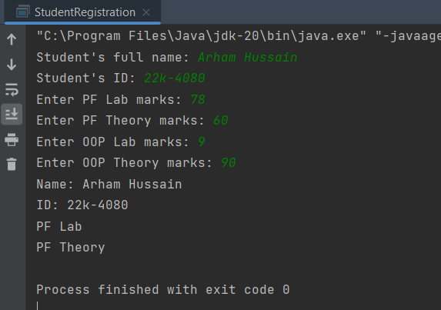
Q3:
public class q3 {
public static <T extends Comparable<T>> T findMax(T[] array) {
T max = array[0];
for (int i = 1; i < array.length; i++) {
if (array[i].compareTo(max) > 0) {
max = array[i];
}
}
return max;
}
public static void main(String[] args) {
Integer[] intArray = {10, 11, 13, 70, 15};
int intHighest = findMax(intArray);
Double[] doubleArray = { 2.48, 2.66, 1.22, 1.30, 3.55 };
double doubleHighest = findMax(doubleArray);
String[] stringArray = { "pink", "red", "orange", "blue", "black" };
String stringHighest = findMax(stringArray);
System.out.println("highest element in integer array is " + intHighest);
System.out.println("highest element in double array is " + doubleHighest);
System.out.println("highest element in string array is " + stringHighest);
}
}
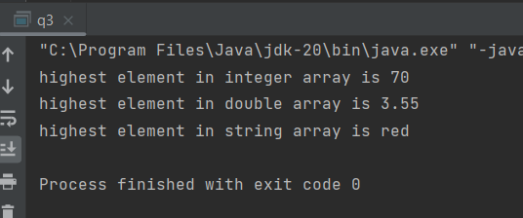
Q4:
import java.util.ArrayList;
import java.util.Collections;
import java.util.List;
public class q4 {
public static void main(String[] args) {
List<Double> list = new ArrayList<>();
list.add(3.5);
list.add(2.5);
list.add(1.8);
list.add(4.2);
// Sorting the list in ascending order
Collections.sort(list);
// Calculating the sum of all the objects in the list
double sum = 0;
for (Number n : list) {
sum += n.doubleValue();
}
// Finding the maximum value of all the objects in the list
Number max = Collections.max(list);
// Printing out the sorted list, sum of all the objects, and maximum value of all the objects
System.out.println("Sorted list: " + list);
System.out.println("Sum of all objects: " + sum);
System.out.println("Maximum value: " + max);
}
}
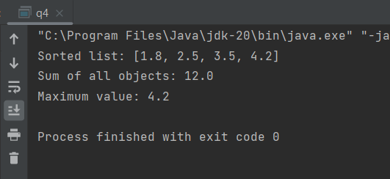
Q5:
import java.io.*;
import java.util.Scanner;
public class q5 {
public static void main(String[] args) {
Scanner sc = new Scanner(System.in);
System.out.print("Enter your designation (Faculty/Student): ");
String designation = sc.nextLine();
try {
File file = new File("Confidential.txt");
if (designation.equalsIgnoreCase("Faculty")) {
// Set RWX permissions for faculty
file.setExecutable(true, false);
file.setWritable(true, false);
file.setReadable(true, false);
} else if (designation.equalsIgnoreCase("Student")) {
// Set R permissions for students
file.setExecutable(false, false);
file.setWritable(false, false);
file.setReadable(true, false);
} else {
System.out.println("Invalid designation entered.");
return;
}
// Show access rights status
System.out.println("Access rights status:");
System.out.println("Executable: " + file.canExecute());
System.out.println("Writable: " + file.canWrite());
System.out.println("Readable: " + file.canRead());
} catch (Exception e) {
System.out.println("Error: " + e.getMessage());
}
}
}
